Upgrade Server Wahana
Server-server Wahana yang ada saat ini dengan spesifikasi sebagai berikut:
Server DB (galera-cluster) @5 server | CPU (Processor) | 2x Intel(R) Xeon(R) CPU E5-2680 v3 @ 2.50GHz 12 Core ( 24 Threads) [ 48 core ]
 | Memory (RAM) | 256 GB
 | Storage | SSD 500 GB  HDD 2 TB  NVME (data DB) 6 TB

Server Apps & Elasticsearch @ 2 server | CPU (Processor) | 2x Intel(R) Xeon(R) CPU E5-2680 v3 @ 2.50GHz 12 Core ( 24 Threads) [ 48 core ]
 | Memory (RAM) | 64 GB
 | Storage | SSD 500 GB  HDD 2 TB  NVME (data ES) 2 TB

Skema penempatan server-server di Datacenter. Saat ini penempatannya adalah di Datacenter Indonet di gedung Cyber 1.
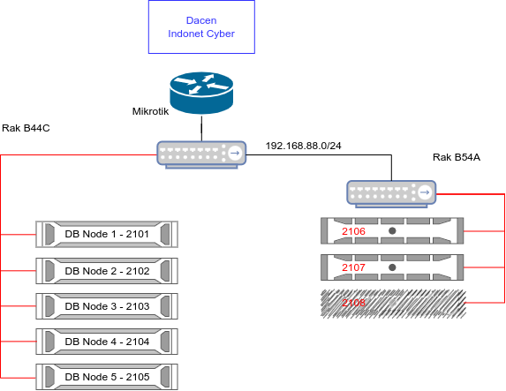
Keterangan:
Server 2108, saat ini kondisi mati total. Mainboard server 2108 sudah tidak berfungsi. Server 2108 merupakan server aplikasi dan Elasticsearch. Fungsi-fungsinya sudah dialokasikan ke server-server lainnya.

Kebutuhan server-server baru adalah untuk menggantikan server-server yang sudah memasuki umur. Dikarenakan sudah mulai masuk umur dan dikhawatirkan error prone di kemudian hari. Tujuannya agar proses-proses pekerjaan dapat bekerja dengan lebih optimal.
Server-server serta network devices yang perlu diupgrade dan/atau ditambahkan.
Server Database | 3 Unit
Server Elasticsearch | 3 Unit
Server Aplikasi | 1 Unit
Router Mikrotik | 1 Unit
Switch manageable | 2 Unit

Skema server-server baru.
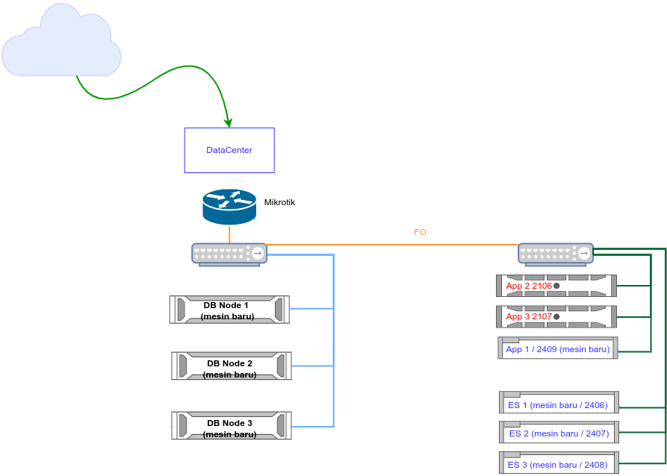
Keterangan:
Apps-2 (2106) dan Apps-3 (2107) adalah mesin lama yang dapat dipergunakan kembali.

Spesifikasi server-server baru dan peruntukkannya.
Tipe Server | Server Database (3 unit)
CPU (Processor) | 2x (dual CPU) 2nd Gen Intel Xeon Scalable Silver 4210 10 core (20 Threads)
RAM (Memory) | 192 GB
Storage | - 1 TB SSD SATA (OS)  - 8 TB HDD SATA (Backup)  - 4 TB NVME (Database)  - Hot Swap Functions
Casing | 2U
Power Supply | Redundant Power Supply
NIC | < 2 x Gigabit

Tipe Server | Server Elasticsearch (3 unit)
CPU (Processor) | 2X (dual CPU) 2nd Gen XEON Scalable SILVER 4208 8 core (16 Threads)
RAM (Memory) | 64 GB
Storage | - 1TB SSD SATA (OS)  - 2TB NVME(Hot ES Data)  - 2TB SSD SATA Warm ES Data)  - 8TB HDD SATA (Cold ES Data)  - Hot Swap Functions
Casing | 2U
Power Supply | Redundant Power Supply
NIC | < 2 x Gigabit

Tipe Server | Server Aplikasi (1 unit)
CPU (Processor) | 2X (dual CPU) 2nd Gen XEON Scalable SILVER 4208 8 core (16 Threads)
RAM (Memory) | 64 GB
Storage | - 1TB SSD SATA (OS)  - 2TB SSD SATA (Apps Container)  - 8TB HDD SATA (Backup, Photos, Logs)  - Hot Swap Functions
Casing | 2U
Power Supply | Redundant Power Supply
NIC | < 2 x Gigabit

Beberapa vendor yang sudah mengirimkan estimasi harga beserta spesfiskasinya.

Vendor:
TokoPCI.com – Toko PCI Computer

Tipe Server | Server Database
Mainboard | Asus z11pa d8
CPU/Processor | 2X (Dual CPU) 2nd Gen XEON Scalable SILVER 4214 12 core (24 Threads)
Memory/RAM | 256 GB
Casing | 2U Indocase
Power Supply | Indocase
Storage | 1TB SSD Sata Samsung EVO 870 (Hot Swap) x1  4TB SSD NVME Samsung 990 Evo x1  2TB SSD Sata Samsung EVO 870 ( Hot Swap) x1  HDD Seagate 8TB HDD Sata ( Hot Swap)
Harga Estimasi | Rp. 94.3jt (indent)

Tipe Server | Server Elasticsearch
Mainboard | Asus z11pa d8
CPU/Processor | 2X (Dual CPU) 2nd Gen XEON Scalable SILVER 4208 8 core (16 Threads)
Memory/RAM | 64 GB
Casing | 2U Indocase
Power Supply | Indocase
Storage | 1TB SSD Sata Samsung EVO 870 (Hot Swap) x1  2TB SSD NVME Samsung 990 Evo x1  2TB SSD Sata Samsung EVO 870 ( Hot Swap) x1  8TB HDD Sata Seagate EXOS (Hot Swap) x1
Harga Estimasi | Rp. 76.5jt (indent)

Tipe Server | Server Aplikasi
Mainboard | Asus z11pa d8
CPU/Processor | 2X (Dual CPU) 2nd Gen XEON Scalable SILVER 4208 8 core (16 Threads)
Memory/RAM | 64 GB
Casing | 2U Indocase
Power Supply | Indocase
Storage | 1TB SSD Sata Samsung EVO 870 (Hot Swap) x1  2TB SSD Sata Samsung EVO 870 ( Hot Swap) x1  8TB HDD Sata Seagate EXOS (Hot Swap) x1
Harga Estimasi | Rp. 72.5jt (indent)

Global Link Distribution (TokPed)

Tipe Server | Server Database
Mainboard | Asus z11pa d8
CPU/Processor | 2X (Dual CPU) 2nd Gen XEON Scalable 4214r 12 core (24 Threads)  + CPU HEATSINK 2UNIT
Memory/RAM | 256 GB
Casing | CASING 2U + Hot Swap Kit
Power Supply | PSU REDUDANT
Storage | SSD 1TB SAMSUNG SATA x1  SSD 4TB SAMSUNG NVME x1  HDD SEAGATE 8TB x1
Harga Estimasi | Rp. 111.300.000 (indent)

Tipe Server | Server Elasticsearch
Mainboard | Asus z11pa d8
CPU/Processor | 2X (Dual CPU) 2nd Gen XEON Scalable 4208 8 core (16 Threads)  + CPU HEATSINK 2UNIT
Memory/RAM | 64 GB
Casing | CASING 2U + Hot Swap Kit
Power Supply | PSU REDUDANT
Storage | SSD 1TB SAMSUNG SATA x1  SSD 2TB SAMSUNG NVME x1  SSD 2TB SATA SAMSUNG x1  HARDDISK 8TB SEAGATE x1
Harga Estimasi | Rp. 74.430.000 (indent)

Tipe Server | Server Aplikasi
Mainboard | Asus z11pa d8
CPU/Processor | 2X (Dual CPU) 2nd Gen XEON Scalable 4208 8 core (16 Threads)  + CPU HEATSINK 2UNIT
Memory/RAM | 64 GB
Casing | CASING 2U + Hot Swap Kit
Power Supply | PSU REDUDANT
Storage | SSD 1TB SAMSUNG SATA x1  SSD 2TB SATA SAMSUNG x1  HARDDISK 8TB SEAGATE x1
Harga Estimasi | Rp. 71.430.000 (indent)

PT. Era Visi Teknologi

Tipe Server | Server Database
Mainboard | Gigabyte
CPU/Processor | 2X (Dual CPU) Intel 3rd gen XEON Scalable SILVER 4310 12 core (24 Threads)
Memory/RAM | 256 GB
Casing | Gigabyte
Power Supply | Gigabyte
Storage | 1 TB SSD Sata (Hot Swap) x1  4 TB SSD NVME x1  8 TB HDD Seagate Sata ( Hot Swap) x1
Harga Estimasi | Rp. 140 juta

Tipe Server | Server Elasticsearch
Mainboard | Gigabyte
CPU/Processor | 1X (Single CPU) Intel 3rd gen XEON Scalable SILVER 4314 16 core (32 Threads)
Memory/RAM | 64 GB
Casing | Gigabyte
Power Supply | Gigabyte
Storage | 1TB SSD Sata (Hot Swap) x1  2TB SSD NVME x1  2TB SSD Sata (Hot Swap) x1  8TB HDD Sata Segate EXOS (Hot Swap) x1
Harga Estimasi | Rp. 115 juta

Tipe Server | Server Aplikasi
Mainboard | Gigabyte
CPU/Processor | 1X (Single CPU) Intel 3rd gen XEON Scalable SILVER 4314 16 core (32 Threads)
Memory/RAM | 64 GB
Casing | Gigabyte
Power Supply | Gigabyte
Storage | 1TB SSD Sata (Hot Swap) x1  2TB SSD Sata (Hot Swap) x1  8TB HDD Sata Segate EXOS (Hot Swap) x1
Harga Estimasi | Rp. 112 juta

Network Devices
Router (1 unit) | Mikrotik RB3011UiAS-RM | Rp. 3.500.000 (estimasi per 1 unit)
Switch Managed (2 unit) | D-Link DGS-1210-20, 16 port | Rp. 2.450.000 (estimasi per 1 unit)

